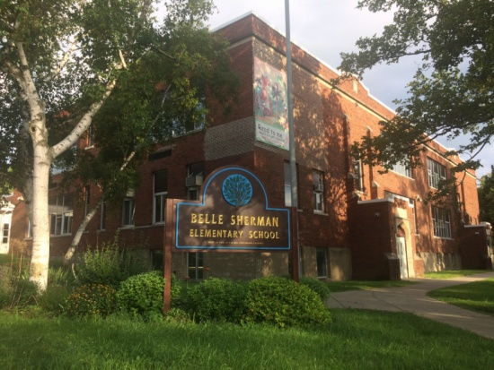

MINIMUM CAPACITY :-

The Minumum intake capacity

of students is between 300-920

children

LIBRARY :-

The Libarary is Available.

CANTEEN:-

The Canteen Facility is Available.

BOARDING :-

No availablility of boarding.

SPORTS :-

There are different categories

sports available.

Girls Volleyball

Boys Volleyball

Football

|  |  |  |
| --- | --- | --- |
| BELLE SHERMAN ELEMENTARY SCHOOL  ITHACA - SCHOOL |  |  |
|  |  |  |
| School Detail :- Belle Sherman School is a public school located in Ithaca, NY, which is in a small city setting. The student population of Belle Sherman School is 316 and the school serves PK-5. At Belle Sherman School, 62% of students scored at or above the proficient level for math, and 47% scored at or above that level for reading. |  |